[cid:image002.jpg@01CD7B9D.2A04EC20](http://www.infoimageinc.com/)

February 2018

InfoIMAGE QA Audit Process

**Pamela Isaac**

Table of Contents

1) Initiate Audit 2

2) Complete Audit Request Form 2

3) Preparing for the Audit 3

Client Services Departments Responsibilities 3

IS Department Responsibilities 3

ISD Department Responsibilities 3

4) QA Conducts Audit - Upon completion of the audit, QA will 4

5) Presentation of Audit Findings 4

6) Create Programming Requests – The 4

7) Audit Conclusion – 4

The Quality Assurance (QA) department provides auditing and analysis of applications by CID. To request an audit, please follow the instructions described below.

# Initiate Audit - Please initiate an Audit Request during the Manager’s Monthly Meeting. Once approved, please follow the procedure described below.

1. Complete Audit Request Form
2. Obtain an Audit Request Application Form from the share drive address below:

/share/QA/AUDIT/ InfoIMAGE_Application_QA_Audit.doc

1. Send Email to QA Team to provide you the Data trac records for all live applications for the CID in question. See the sample below from UTCU

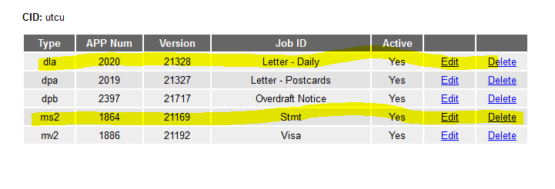

1. Complete the Audit Request Form (ARF) with the application details taken from the DataTRAC screenshot above.
2. Please provide a due date for the audit to be completed.
3. Please email the completed form to “Alias QA-STAFF” and schedule a request for QA resources by identifying a date and time.
4. QA staff time will be assigned for each application and the QA calendar will be updated accordingly.
5. Preparing for the Audit
6. Create a Programming Request (PR) and attach the completed ARF. Please be sure include and specify due dates to expedite the processing of your request. IS will open a JEF for each application and insert the due date from the completed ARF and assign the JEF to a programmer.
7. The summary task list below identifies responsibilities for each department staff:

### Client Services Departments Responsibilities

Client Services departments include Account Services (AS), Account Management (AM), Sales and Implementation (IM).

* List all JEFs for apps provide to IS.
* Update SOWs with all the relevant JEF info
* Provide link to SOW for Audit to QA

### **IS Department Responsibilities**

* Export all the projects (List is from DataTRAC) for this app from production to /is/qa/<CID>/AuditYYYY/<JID>/
* Like this for daily letters UTCU will be in --- /iss/qa/UTCU/Audit2018/DL/
* Provide print samples from the print files from
* 4.oz
* Hvy
* Move JEFs to QA request

### ISD Department Responsibilities

InfoTRAC – Provide details (as specified on contract), e.g.:

* Inventory
* Job status
* Online proofing
* Mail tracking
* Eside- update SOW with all recent updates
* Eside
* AI site
* SSO
* DSO
* Member Site

Sync production code to stage before audit

1. QA Conducts Audit - Upon completion of the audit, QA will produce two reports per application, a “Findings” report will be submitted in word format and “Basic Functional Testing” presented in excel format. The Findings report will consist of three sections:
   1. SOW updates needed
   2. Code updates needed
   3. Items QA was Unable to verify ( lack of data, lack of information)
2. Presentation of Audit Findings – Upon request by the Audit initiator, QA will present audit findings. The Audit initiator is responsible for coordinating the meeting and inviting concerned department staff and interested stakeholders. At minimum, the meeting outcome should:
   1. Identify updates that should be completed internally by InfoIMAGE and those that should be completed by the client.
   2. Itemize a list of updates to create PR’s
3. Create Programming Requests – The Audit initiator is responsible for creating PR’s and completing the PR form with appropriate completion and/or due dates. Once a PR has been created, the PR will be processed according to the standard procedure.
4. Audit Conclusion – Once a list has been generated itemizing all PRs, the Audit initiator can conclude the Audit process by convening a final meeting and/or sending an email notification to interested stakeholders validating the conclusion of the audit results.